**Aidan Brown**

**GEOG 501 Fall 2023**

# Deliverable 1

Screen capture of the Catalog pane of your data in ArcGIS Pro showing all the data layers for

North Vancouver. Properly expand the catalog tree to see all the contents of the folder that contains your data:

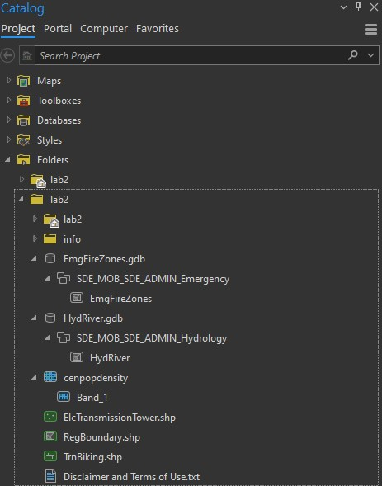

# Deliverable 2

Screen capture of the Contents of your map showing all the data layers for North Vancouver in a single map:

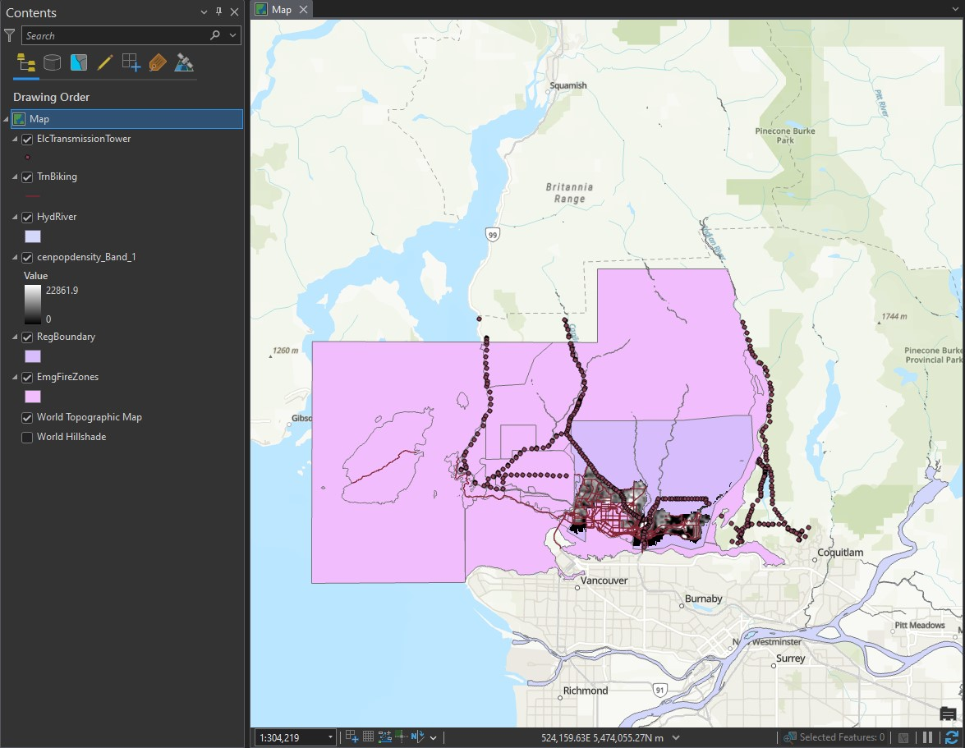

# Deliverable 3

How many different files does the shapefile of biking routes consist of? This refers to the files your downloaded, not any files that may have been added by ArcGIS Pro after you work with the shapefile. What are their file extensions?

Four total files were included with the biking shapefile. The file extensions are:

**.dbf**

**.prj**

**.shp**

**.shx**

# Deliverable 4

What is the geometry type of the boundary shapefile?

The **RegBoundary** shapefile's geometry type is a **polygon**. The attribute table specifically states that it is the shape of a ***polygon ZM***.

# Deliverable 5

How many feature classes does the creeks geodatabase contain?

The creeks (HydRiver.gdb) contains **one** feature class.

# Deliverable 6

How many transmission towers are there?

There are **386** transmission towers, according to the attribute table.

# Deliverable 7

What is the area in hectares of fire response zone C1 (rounded to zero decimals)?

Area in hectares of zone C1 is 215.0.

# Deliverable 8

How many different attributes are there for each biking route?

There are 49 different attributes for each biking routes.

# Deliverable 9

What do the pixel values of the population density raster represent?

The pixels are representing the population density within the area.

# Deliverable 10

What surface area does each pixel of the population density raster represent?

The colour scale shows that if the pixel is brighter, then the population is a denser, whereas if the pixel is darker then the population is sparser.